1. **Purpose and Scope:**

The purpose of this document is to define and describe the High Level Design(HLD) of the Takeaway restaurant

1. **General Assumptions:**

| Unique ID | Description of Assumption |
| --- | --- |
| GA001 | Screenshots in the document are for illustration purposes only and have been taken from several takeaway websites [1] and [2]. They are included in the document to reflect the business process. Final screen design will be based on mutual agreed design between the team |
| GA002 | Menus, headers, and footers in the screenshots are shown for illustration purposes only and have been taken from several takeaway websites [1] and [2]. |
| GA003 | Any input fields on the screen will be validated for basic and standard input format for that specific field, e.g., numeric, email validations etc. |
| GA004 | Any further updates to the design and the architecture would be included in the document |

1. **Solution Overview:**

**3.1 Front-end pages:**

* Landing Page
* View Menu
* About
* Gallery
* Contact us
* Login
* Register
* Register Confirmation
* Payment
* Order Summary

**3.2 DB tables:**

* ORDER
* CUSTOMER
* PAYMENT
* ADDRESS
* MENU_ITEM

**3.3 Code repository:**

* Github

https://github.com/jnguyen38/EE417-Group8

**3.4 Server deployment:**

**TBD**

1. **Solution:**
   1. **Landing Page:**
      1. **Screen Overview:**

* This is the entry point for the user to the website, that is, the website’s welcome screen.
* Consists of all the useful information and important links.
* Has a navigation menu bar with all the important links like View Menu, About, Gallery, Contact us, Login, Register
* Has a hamburger menu on the Menu bar: showing offers, and best-sellers.
  + 1. **Layout:**

**Welcome screen:**

| Item | Type | Description |
| --- | --- | --- |
| Background Image | Image | An image of a dish served at the restaurant. Filename: home_bg.jpeg |
| Order Now | Button(large) | Allows the user to navigate to the View Menu screen, from where the orders can be made |
| Opening Hours | List | A list that contains the opening hours of the restaurant:  Monday 02:00 pm - 10:00 pm  Tuesday 02:00 pm - 01:00 am  Wednesday 02:00 pm - 01:00 am  Thursday 07:30 pm - 01:40 am  Friday 02:00 pm - 02:45 am  Saturday 02:00 pm - 02:45 am  Sunday 02:00 pm - 12:45 am |
| Awards |  | An image that shows a certification acheived. Filename: award.png |

**Navigation menu layout:**

| Menu | Activity | Description |
| --- | --- | --- |
| Home | Landing Page | Clicking this item would take the user to the landing page |
| View Menu | View Menu | Allows the user to navigate to the View Menu screen, from where the orders can be made |
| About | About Page | Allows the user to navigate to the About section, that would contain information about the restaurant’s story and philosophy |
| Gallery | Picture Gallery | A picture gallery of all food and the kitchen. Filename: gallery1.jpeg-gallery9.jpeg |
| Contact us | Contact page | Contact page in case the customer wants to reach out to the restaurant. |
| Login | Login page | Takes the customer to the login form |
| Register | Registration page | Takes a new customer to the registration form |

**Hamburger menu:**

| Item | Type | Description |
| --- | --- | --- |
| Bestseller list | List | All the bestselling items at the restaurant are presented as a list in this menu |
| Offer list | List | All the items with an ongoing offer at the restaurant are presented as a list in this menu |

* + 1. **Screen examples:**

**Background image and Order Now Button:**

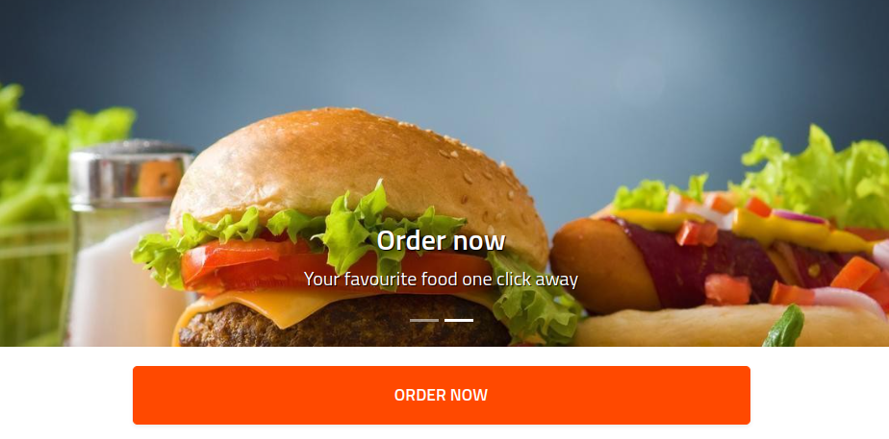

**Opening hours section:**

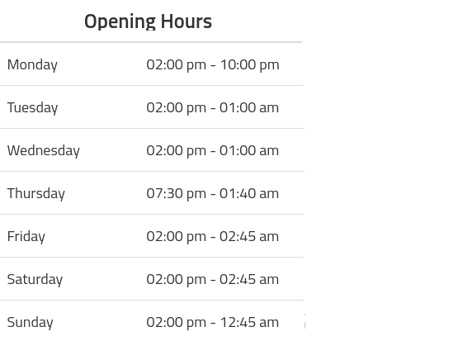

**Awards section(image shared separately):**



* 1. **View Menu Page:**
     1. **Screen Overview:**
* Menu- Shows a list of dishes available on the left hand side of the page.
* (+) button- Allows user to order the dishes using the (+) button next to the dish name on the menu. Clicking on + again increases the quantity by 1 in the cart section
* (-) button- This would deduct the quantity by 1 in the cart section. Next to the (+) button on the menu
* Amount calculation logic: On clicking (+), the item should get added to the cart section along with its cost. The total amount should get recalculated and displayed on the cart. On clicking (-), the item should get deducted by 1 from the cart section along with its cost. The total amount should get recalculated and displayed on the cart.
* Cart section: On the right hand side of the page. The item should get added to the cart on clicking the (+) button. The cost of the item should get displayed next to the item name. There should be a field for the calculation of the Total Amount.
* Checkout button: Clicking on this should take the user to payment page
  + 1. **Layout:**

**Menu: Left Section**

| Item | Type | Description |
| --- | --- | --- |
| Dish Type | Header | * Main header that describes the type of dish in the Dish Name sublist * Values are taken from the MENU_ITEM table |
| Dish Name | Text field/ List | * Name of the dish served * All dishes are organised in a list. * List to be shared in a separate file * Values are taken from the MENU_ITEM table |
| Dish Price | Text field | * Value of dish price taken next to the dish name * Values are taken from the MENU_ITEM table |
| (+) | Button | * Button next to the dish name on the menu. * Allows user to order the dishes. * Clicking on + again increases the quantity by 1 in the cart section |
| (-) | Button | * Next to the (+) button on the menu. * Clicking on this would deduct the quantity by 1 in the cart section * Validation required: If the dish is not in the cart already, then clicking this would not do anything |

**Cart section:**

| Item | Type | Description |
| --- | --- | --- |
| Dish Name | Text field | * Name of the dish served * All dishes ordered are organised in a list. |
| Dish Price | Text field | * Value of dish price taken next to the dish name |
| (+) | Button | * Button next to the dish name on the Cart Section. * Clicking on + again increases the quantity by 1 in the cart section |
| (-) | Button | * Next to the (+) button on the menu. * Clicking on this would deduct the quantity by 1 in the cart section |
| Total Amount | Text field | * Calculates the total amount based on the quantity of dishes added * Should automatically recalculate amount on change(addition, deletion, modification) of items in the cart. |
| Checkout | Button | * Clicking on this should take the user to payment page |

* + 1. **Screen examples:**

**Menu list:**

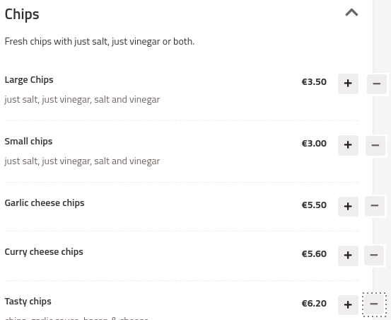

**Cart section**

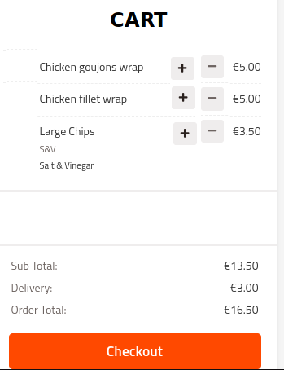

* 1. **About Page:**
     1. **Screen Overview:**
* Consists of two headers- Our Story and Our Philosophy
* Image: An Image of the food or the chef
* Our Story: Tells the story of the takeaway restaurant. Write-up to be shared separately
* Our Philosophy: Tells the philosophy of the takeaway restaurant. Pending write-up
  + 1. **Layout:**

| Item | Type | Description |
| --- | --- | --- |
| Our Story | Header | * H2 |
| Story | Text | * The story of the restaurant in 100-200 words * Write-up to be shared separately |
| Our Philosophy | Header | * H2 |
| Philosophy | Text | * The Philosophy of the restaurant in 100-200 words * Write-up to be shared separately |

* + 1. **Screen examples:**

NA

* 1. **Gallery Page:**
     1. **Screen Overview:**
* Pictures of food and the kitchen
* To be shared separately
  + 1. **Layout:**

NA

* + 1. **Screen examples:**

NA

* 1. **Contact Us Page:**
     1. **Screen Overview:**
* Headings: Opening hours, Address, Email, and Phone number, Social media(Facebook, Instagram and Twitter links)
  + 1. **Layout:**

| Item | Type | Description |
| --- | --- | --- |
| Address | Header | * H1 |
| Address value | Text field | * Dublin City University, Collins Ave Ext, Whitehall, Dublin 9 |
| Email | Header | * H1 |
| Emailvalue | Text field | * abc@gmail.com |
| Phone number | Header | * H1 |
| Phone value | Text field | * 11223344 |
| Social Media | Header | * H1 |
| Social Media links | Hyperlinks | * Various hyperlinks for Facebook, Instagram and Twitter with respective logos |

* + 1. **Screen examples:**



* 1. **Login Page:**
     1. **Screen Overview:**
* For the user/ owner to login to the system
* Separate credentials for the owner to login with additional privileges
* Form with text boxes: Email ID, Password
* Checkbox: Remember me
* Buttons/ hyperlinks: Login, Forgot Password, Register
  + 1. **Layout:**

| Item | Type | Mandatory/ Optional | Description |
| --- | --- | --- | --- |
| Email ID | Text box | Mandatory | * Textbox for user to input email ID * Email input validations required |
| Password | Text box | Mandatory | * Textbox for user to input password * Masked text |
| Remember me | Checkbox | Optional | * User checks this checkbox if their login credentials are to be stored in the system |
| Login | Button | NA | * Login button allows user/admin to authenticate themselves * Separate privileges for admin/ user |
| Forgot Password | Hyperlink | NA | * Takes user to “Forgot Password” page |
| Register | Button | NA | * Takes user to “Register” page |

* + 1. **Screen examples:**

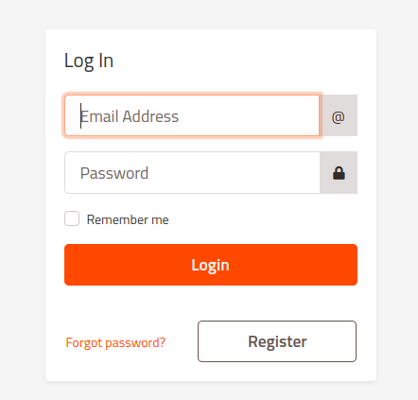

* 1. **Register Page:**
     1. **Screen Overview:**
* Form: First name, Last name, Email, Password, Confirm password, Phone
* Checkboxes: Send updates by email, T&C agreement. Pending write-up
* Buttons: Register
  + 1. **Layout:**

| Item | Type | Mandatory/ Optional | Description |
| --- | --- | --- | --- |
| First Name | Text box | Mandatory | * Textbox for user to input First Name * Text input validations required |
| Last Name | Text box | Mandatory | * Textbox for user to input Last Name * Text input validations required |
| Email ID | Text box | Mandatory | * Textbox for user to input email ID * Email input validations required |
| Password | Text box | Mandatory | * Textbox for user to input password * Masked text |
| Password Confirm | Text box | Mandatory | * Textbox for user to input password * Masked text |
| Telephone | Phone | Mandatory | * Textbox for user to input Phone number * Phone number validations required |
| Agree Terms and Conditions | Checkbox | Mandatory | * User checks this checkbox if they would like to agree with the Terms and Conditions. Write-up: “By clicking Register, you agree to the Terms and Conditions” |
| Terms and Conditions | Hyperlink | NA | * Popup screen shown on the page on clicking link * Has the Terms and Conditions found in the Appendix |
| Register | Button | NA | * Register button allows user to complete registration * Clicking on the button takes user to Registration Confirmation page * A mail is sent to the customer’s email ID mentioned * Validations required: Mandatory field validation. Register button would only get enabled when:  1. All the mandatory fields are entered 2. All the Terms and conditions are agreed upon(by checking the check box) |

* + 1. **Screen examples:**

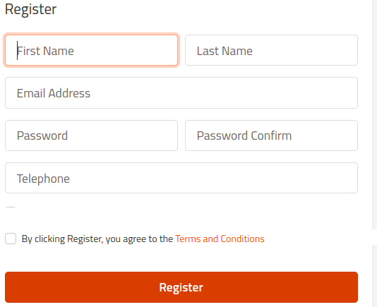

* 1. **Register Confirmation Page:**
     1. **Screen Overview:**
* Used when registration is completed and the data is stored in DB table- USER
* Write-up: “Thank you for completing your registration. Please complete the login”
  + 1. **Layout:**

NA

* + 1. **Screen examples:**

NA

* 1. **Payment Page:**
     1. **Screen Overview:**
* Order Details section: Shows everything the customer ordered along with the respective quantites and price
* Personal Information form: First name, Last name, Email, Phone. Auto-filled from CUSTOMER table
* Delivery address form: Text boxes to enter delivery address information. Auto-filled if customer has saved delivery information on the customer details page.
* Payment options: Card Payment, Cash on Delivery.
* Payment form: Forms corresponding to Card payment type to enter payment information. Also has checkbox to remember payment details
* Payment button: “Pay” button that leads to the payment portal. Add order ID to ORDER table
  + 1. **Layout:**

**Order Details section:**

| Item | Type | Description |
| --- | --- | --- |
| Dish Name | Text field | * Name of the dish served * Uneditable |
| Dish Price | Text field | * Value of dish price taken next to the dish name |
| Delivery charges | Text field | * Add 3 euros delivery charges to every order |
| Total Amount | Text field | * Calculates the total amount based on the quantity of dishes added * Total Amount should include 3 euros Delivery Charges |

**Personal Information form:**

| Item | Type | Mandatory/ Optional | Description |
| --- | --- | --- | --- |
| First Name | Text box | Mandatory | * Textbox for user to input First Name * Text input validations required * Should be auto-populated if the customer is logged in |
| Last Name | Text box | Mandatory | * Textbox for user to input Last Name * Text input validations required * Should be auto-populated if the customer is logged in |
| Email ID | Text box | Mandatory | * Textbox for user to input email ID * Email input validations required * Should be auto-populated if the customer is logged in |
| Telephone | Phone | Mandatory | * Textbox for user to input Phone number * Phone number validations required * Should be auto-populated if the customer is logged in |

**Delivery address form:**

| Item | Type | Mandatory/ Optional | Description |
| --- | --- | --- | --- |
| Address Line 1 | Text box | Mandatory | * Textbox for user to input Address Line 1 * Text input validations required * Should be auto-populated if the customer is logged in and the address is present in the customer profile |
| Address Line 2 | Text box | Optional | * Textbox for user to input Address Line 2 * Text input validations required * Should be auto-populated if the customer is logged in and the address is present in the customer profile |
| City | Text box | Mandatory | * Textbox for user to input City * Text input validations required * Should be auto-populated if the customer is logged in and the address is present in the customer profile |
| Postcode | Text box | Mandatory | * Textbox for user to input Postcode * Phone number validations required * Should be auto-populated if the customer is logged in and the address is present in the customer profile |

**Payment section:**

| Item | Type | Mandatory/ Optional | Description |
| --- | --- | --- | --- |
| Cash | Radio Button | Mandatory/ Optional | * User selects this if cash payment is required |
| Card | Radio Button | Mandatory/ Optional | * User selects this if Card payment is required * On selecting this payment mode, a new form is displayed below showing textboxes for card number, expiry date and CVV |
| Card Number | Text box | Mandatory | * Textbox for Card number input * Card number input validations required. 16 digit numbers only |
| Expiry Date | Date | Mandatory | * Textbox for user to input Expiry Date * Validations: Expiry date cannot be in the past |
| CVV | Number | Mandatory | * Three digit CVV number * Validation: Only numeric values between 0-999 should be accepted |

* + 1. **Screen examples:**

**Order Details section:**

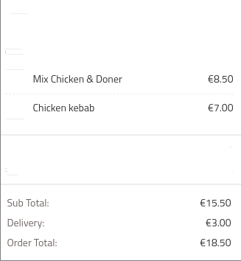

**Personal Information form:**

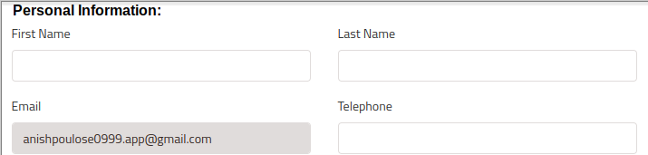

**Delivery address form:**

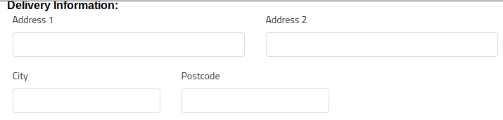

**Payment section:**

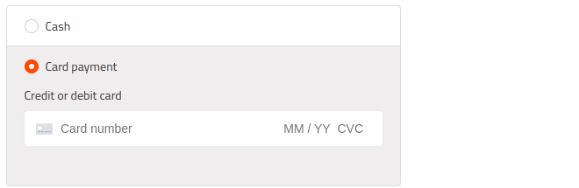

* 1. **Order Summary Page:**
     1. **Screen Overview:**
* Large Bold Text: “Your order has been confirmed!”. Order ID(Primary key for ORDER table) should also be mentioned
* Display of Items: The order summary should display all the items that the customer has added to their cart or ordered ie all the items on clicking Checkout button
* Cost calculation: The total amount of the cart on clicking the Checkout button
* Delivery information: Delivery address information taken from payment page
* Payment information: Payment information taken from payment page. Appropriate masking to be done for payment info like card numbers etc
* Save Invoice button: Save the Order summary page in a pdf file. Pending discussion because this is complicated
  + 1. **Layout:**

| Item | Type | Description |
| --- | --- | --- |
| Thank you message | Text Description(Bold) | * “Your order has been confirmed! Here is your Order ID- <Order ID>” * Order ID should be taken from ORDER table |
| First Name | Text Field | * First Name of the customer |
| Last Name | Text Field | * Last Name of the customer |
| Email ID | Text Field | * Email ID of the customer |
| Telephone | Text Field | * Telephone of the customer |
| Payment Method | Text field | * Displays the payment method. Values accepted- Cash, Card |
| Address | Text field | * Address taken from the ORDER table for the customer |
| Delivery by | Time field | * The countdown timer of 45 minutes begins when the order is confirmed * Add 45 minutes to system time on which the order was confirmed |

* + 1. **Screen examples:**

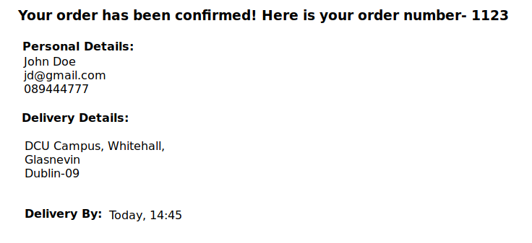

1. **Integration:**
2. **Feedback**

Admin privileges for the owner/ admin- pending discussion- Anish

Images shared separately- Anish

Pending forgot password screen- Anish

Pending writeups- Anish

Terms and Conditions write-up- Anish